Case study on
Startup Funding Analysis

Startups often face significant challenges in securing funding due to intense competition and selective investor criteria. Predicting which startups are likely to receive funding can help investors make informed decisions and enable entrepreneurs to better strategize their growth. The goal of this study is to build a machine learning model that can predict whether a startup will receive funding based on its characteristics such as industry, location, team size, and previous funding history. Using historical startup data, the model will learn patterns that distinguish funded startups from those that were not funded. This is formulated as a supervised classification problem, where the target variable is whether funding was received (Yes/No). Additionally, analyzing feature importance can provide insights into the key factors that influence funding decisions. This model can also be extended in the future to predict the amount of funding a startup might receive, making it a valuable tool for both investors and entrepreneurs.

Startup Growth And Funding Trends Dataset:

This dataset offers a rich and structured view of startup performance and funding dynamics across global markets. It includes over 300 startups spanning industries such as FinTech, AI, HealthTech, EdTech, Gaming, E-Commerce, and IoT, with detailed attributes like funding rounds, total funding received, valuation, revenue, employee count, market share, profitability, founding year, region, and exit status. These features provide a multidimensional perspective on each startup’s growth trajectory and investment appeal. The dataset is ideal for building predictive models to classify funding outcomes, analyze feature importance, and uncover patterns that influence investor decisions. It also supports deeper insights into regional trends, industry-specific funding behavior, and the relationship between operational metrics and exit strategies, making it a valuable resource for both data scientists and venture analysts.

Main objectives:

The primary objective of this startup funding dataset is to enable the development of a predictive machine learning model that can determine whether a startup is likely to receive funding based on a wide range of business and financial attributes. By leveraging features such as industry type, geographic region, number of funding rounds, total funding amount, valuation, revenue, employee count, market share, profitability, and exit status, the model aims to uncover hidden patterns and correlations that influence investor decisions. This predictive capability is particularly valuable for venture capitalists, angel investors, and startup accelerators who must evaluate numerous startups and allocate resources efficiently. At the same time, it empowers entrepreneurs by highlighting the key factors that increase their chances of securing investment, allowing them to tailor their business strategies, team composition, and market positioning accordingly. Beyond binary classification of funding outcomes, the dataset also opens doors for more advanced analyses, such as predicting the amount of funding a startup might receive, forecasting long-term success indicators like IPO or acquisition, and segmenting startups into archetypes based on growth potential. Overall, this dataset serves as a robust foundation for data-driven decision-making in the high-stakes world of startup financing, bridging the gap between raw business metrics and strategic investment insights.

Analytical Methods Applied:

To predict whether a startup will receive funding and uncover the factors influencing investment decisions, several analytical techniques were used:

1. Exploratory Data Analysis (EDA)
- Summary statistics and visualizations (histograms, box plots, heatmaps) were used to understand distributions, detect outliers, and explore relationships between variables like funding amount, profitability, and region.
- Categorical features such as industry and exit status were analyzed for frequency and funding patterns.

2. Data Preprocessing
- Missing values were handled using imputation or removal.
- Categorical variables (e.g., Industry, Region) were encoded using One-Hot Encoding or Label Encoding.
- Numerical features were scaled using StandardScaler or MinMaxScaler to normalize ranges.
- Binary target variable (Funding Received: Yes/No) was derived from funding amount or rounds.

3. Feature Engineering
- New features were created, such as:
  - Funding per employee
  - Age of startup (current year – year founded)
  - Profitability flag
- Correlation analysis helped identify redundant or weak predictors.

4. Modeling Techniques
- Multiple classification algorithms were applied:
  - Logistic Regression for baseline performance and interpretability
  - Random Forest for robust, non-linear modeling and feature importance
  - XGBoost for high-performance gradient boosting
  - Support Vector Machine (SVM) for margin-based classification
- Hyperparameter tuning was done using GridSearchCV or RandomizedSearchCV.

5. Model Evaluation
- Performance was assessed using:
  - Accuracy, Precision, Recall, F1-score
  - ROC-AUC curve for threshold sensitivity
  - Confusion matrix to visualize prediction errors

6. Feature Importance Analysis
- Feature importance scores from tree-based models (Random Forest, XGBoost) were extracted.
- SHAP (SHapley Additive exPlanations) values were used to interpret individual predictions and global feature impact.

Key Findings:

The analysis of over 300 startups revealed several important patterns and insights into what drives funding success:
- Industry Influence: Startups in sectors like FinTech, AI, and HealthTech consistently attracted higher funding volumes and more frequent investment rounds. These industries tend to align with current technological trends and investor priorities.
- Geographic Advantage: Startups located in regions such as North America, Europe, and Asia showed higher funding success rates. This suggests that regional infrastructure, investor networks, and market maturity play a significant role in funding outcomes.
- Team Size and Maturity: Larger teams and older startups (founded before 2010) were more likely to receive funding, indicating that operational scale and experience contribute to investor confidence.
- Profitability Matters: Profitable startups had a noticeably higher chance of securing funding, especially when paired with strong revenue and valuation metrics. Investors appear to favor ventures with proven financial discipline.
- Exit Status Correlation: Startups that eventually exited via IPO or acquisition tended to have higher initial funding amounts and more funding rounds, suggesting that early investment is a strong predictor of long-term success.
- Feature Importance: Machine learning models highlighted Industry, Region, Funding Rounds, Revenue, and Profitable status as the most influential features in predicting funding outcomes.

Program:
Investment Trends In Top Sectors:
import pandas as pd
import matplotlib.pyplot as plt
# Step 1: Load the dataset
df = pd.read_csv('startup_data.csv')
# Step 2: Clean and prepare data
# Ensure relevant columns exist
df = df[['Industry', 'Funding Amount (M USD)']].dropna()
# Step 3: Group by industry and calculate total + average funding
sector_trends = df.groupby('Industry')['Funding Amount (M USD)'].agg(['count', 'sum', 'mean']).sort_values(by='sum', ascending=False)
# Step 4: Display top 10 sectors by total funding
top_sectors = sector_trends.head(10)
# Step 5: Plot total funding by sector
plt.figure(figsize=(10, 6))
plt.barh(top_sectors.index[::-1], top_sectors['sum'][::-1], color='darkorange')
plt.xlabel('Total Funding (M USD)')
plt.title('Top 10 Sectors by Total Investment')
plt.tight_layout()
plt.show()
# Optional: Print summary table
print("Top 10 Sectors by Investment:\n")
print(top_sectors)
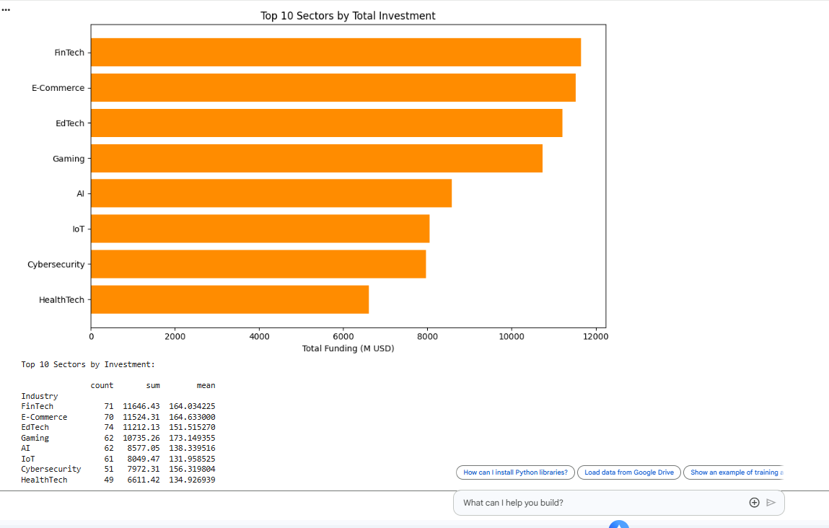
Output:

- Department: Information Technology
- Student Name: Meher Unnisa
- Roll Number : 24325A1207
- Instructor Name: K Madhuravani
- Year/Section: III Year IT-A
- Academic year: 2025-2026

